OOP lab 9

Q1
Source Code
class X:
def __init__(self, x):
self.x = x

def __add__(self, y):
return self.x + y.x

ob1 = X(2)
ob2 = X(1.95)
ob3 = X("Nabeel")
ob4 = X("Rizwan")

print(ob1 + ob2)
print(ob3 + ob4)

Output
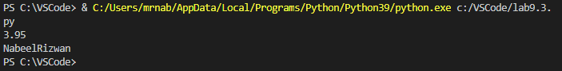

Q2
Source Code
class useMF():
def __init__(self, num):
self.num = num

def __hex__(self):
return hex(self.num)

nabeel = useMF(100)
print(nabeel.__hex__())

Output
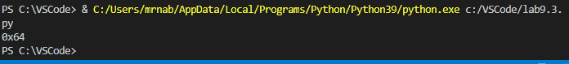

Q3
Source Code
import math
class useMF():
def __init__(self, num):
self.num = num

def __floor__(self):
return math.floor(self.num)

nabeel = useMF(-23.11)
print(nabeel.__floor__())

Output
